Unified Modeling Language (UML)
UML is a standardized modeling language used in software engineering to visualize, specify, construct, and document the artifacts of a software system.

How UML Works:
Modeling: UML offers a suite of diagrams to represent various aspects of a system.
- Structural Diagrams: Show the static structure of a system
- Behavioral Diagrams: Show the dynamic aspects of a system
- Abstraction: UML helps in abstracting complex systems into simpler, more manageable models. For instance, class diagrams help in modeling the system's static structure, while sequence diagrams capture interactions between objects over time.
- Standardization: UML is an industry-standard notation developed by the Object Management Group (OMG).
UML emerged to unify and consolidate these disparate notations into a single, cohesive modeling language. It integrates concepts from OMT, Booch, and OOSE, incorporating their strengths and offering a comprehensive set of diagrams and methods for modeling complex systems.
UML Model Example
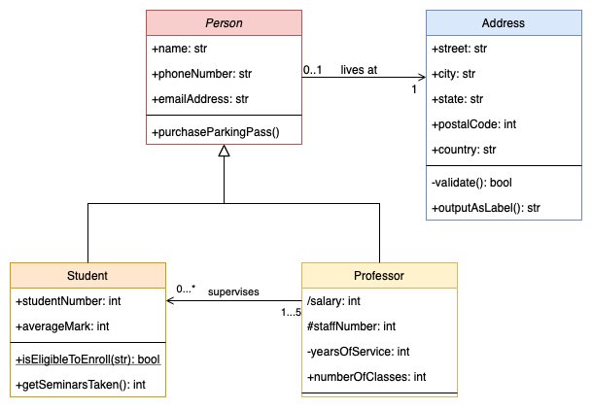

Parts of a Composite Structure Diagram
Classifier (or Class):
- Representation: The class or classifier that is being modeled. It can represent any classifier, but typically, it's a class that contains internal structure.
- Notation: Represented by a rectangular box with the class name at the top.

Parts (or Parts Instances):
  - Representation: These are the components or objects that are part of the classifier’s internal structure.
  - Notation: Typically depicted as smaller rectangles or circles within the classifier, connected by lines.
Ports:
  - Representation: Points of interaction between the classifier and its environment or between parts inside the classifier.
  - Notation: Shown as small squares or circles on the edges of the classifier or parts.
Connectors:
  - Representation: Associations between parts, or between parts and ports, indicating how they are connected and interact.
  - Notation: Lines or arrows connecting parts or ports, often with labels indicating the type of interaction.
Internal Structure:
  - Representation: The arrangement and organization of parts and their connectors within the classifier.
  - Notation: Displayed within the main classifier rectangle, showing the internal components and their connections.
Collaboration:
  - Representation: The interactions and relationships between the parts of the classifier.
  - Notation: Illustrated by connectors and the arrangement of parts within the classifier.
Artifacts (optional):
  - Representation: Physical entities such as files or documents that are part of the system’s internal structure.
  - Notation: Represented by artifacts (usually depicted as a rectangular box with a folded corner) connected to parts or classifiers.
Structured Classes:
  - Representation: Classes that are used to define the internal structure of the classifier, including the classes of parts.
  - Notation: Shown as classes with their own internal structure and interactions.
Constraints (optional):
  - Representation: Conditions or rules that must be adhered to by the internal structure of the classifier.
  - Notation: Represented by notes or constraints attached to parts, connectors, or the classifier.
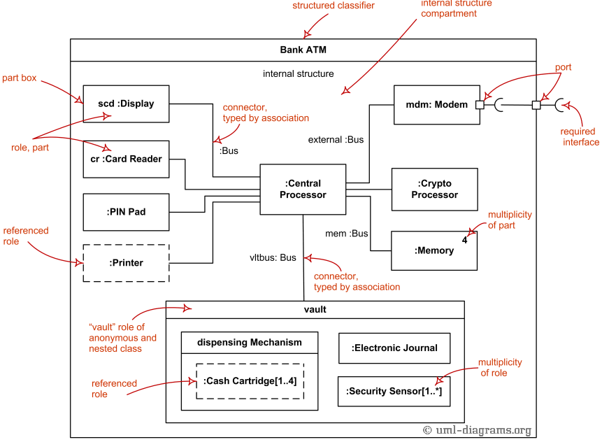
Use Case Diagram:
- Representation: A functionality or service provided by the system.
- Notation: Represented by an oval shape with the use case name inside.
Class Diagram:
- Representation: Defines a blueprint for objects, including attributes and methods.
- Notation: Represented by a rectangular box divided into three compartments:
  - Top: Class name
  - Middle: Attributes
  - Bottom: Operations (methods)

Sequence Diagram:
- Representation: Represents an individual object or participant in the interaction.
- Notation: Vertical dashed line with the object’s name at the top.
State chart Diagram:
- Representation: Represents a condition or situation of an object.
- Notation: Rounded rectangle with the state name inside.
Activity Diagram:
- Representation: Represents a task or action in the workflow.
- Notation: Rounded rectangle with the activity name inside.

Forward Engineering
- Forward engineering is the process of designing and building a system from its requirements and specifications into a working software system.
- It involves creating models and code that progressively translate requirements into a functional application.

Reverse Engineering
- Reverse engineering is the process of analyzing and extracting the design and functionality of an existing system to understand or improve it.
- It involves deconstructing a software system to derive models, documentation, or specifications from the implemented code.

Round-Trip Engineering
- Round-trip engineering is the iterative process of synchronizing changes between design models and source code to ensure consistency throughout the development lifecycle.
- It involves continuously updating models based on code changes and vice versa, facilitating a seamless integration between design and implementation.

Functional Model
Definition: The functional model represents the functionality of the system and how it performs tasks or operations.
Explanation: It focuses on what the system does by describing the functions or processes, often using diagrams like use case diagrams and activity diagrams to capture system behaviors and workflows.
Key Points:
- Use Case Diagram: Captures interactions between users (actors) and the system.
- Activity Diagram: Illustrates the flow of activities and processes within the system.

Object Model
Definition: The object model describes the static structure of the system, detailing the objects, their attributes, and the relationships between them.
Explanation: It focuses on what entities are involved in the system and how they are organized, typically using class diagrams to represent classes, objects, and their relationships.
Key Points:
- Class Diagram: Shows the classes, their attributes, methods, and relationships such as inheritance and associations.

Dynamic Model
Definition: The dynamic model represents the behavior of the system over time, detailing how objects interact and change state in response to events.
Explanation: It focuses on how the system responds to stimuli and manages state transitions, often using sequence diagrams, statecharts, or interaction diagrams to capture dynamic interactions and state changes.
Key Points:
- Sequence Diagram: Illustrates interactions between objects in a specific sequence of events.
- Statechart Diagram (State Machine Diagram): Depicts the states of an object and the transitions between these states based on events.

